Automate the Boring Stuff

Programming Basics

* Continue to go to next iteration of the loop
* Installing packages

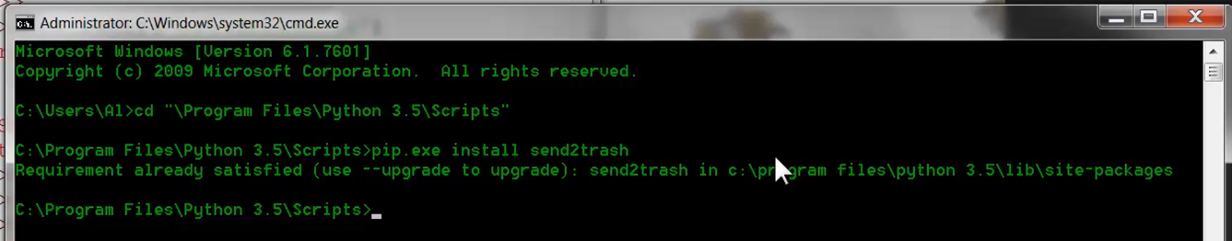

Regular Expressions

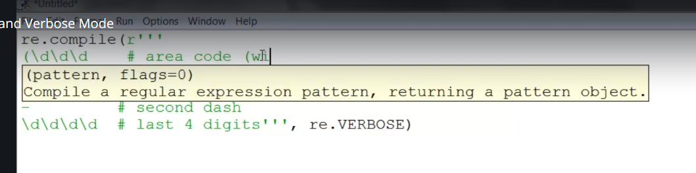

* Verbose allows us to add the spaces and comments to make long re more understandable
* Can pipe multiple arguments for 2nd “argument” if necessary

OS

* OS package is very useful for working with files and file paths

SHUTIL

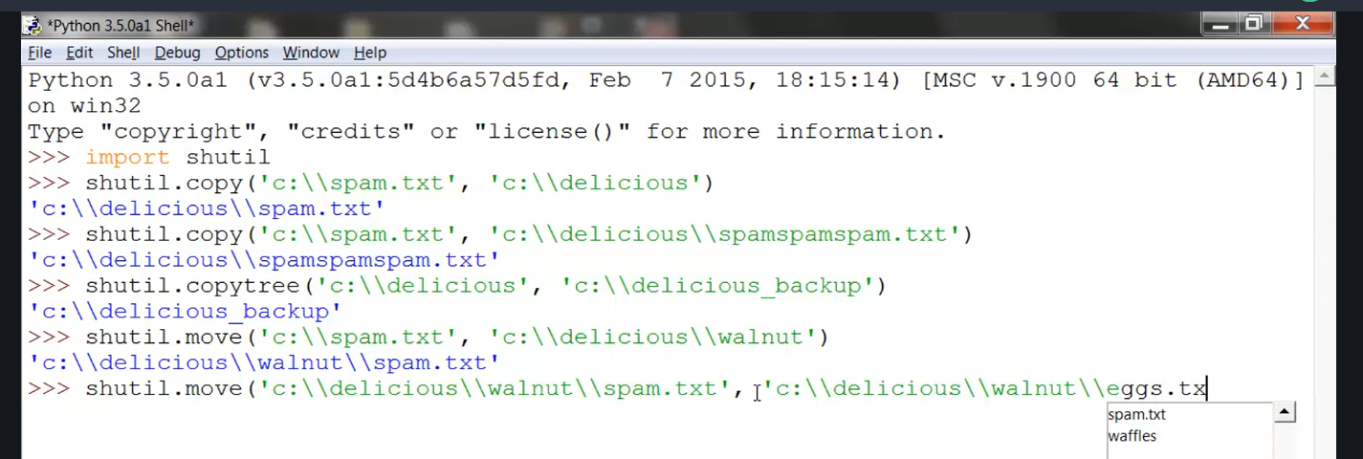

* Useful for moving files around